**Strings in Python**

-- In python, anything that you enclose between single or double quotation mark is considered as a string.

-- A string is essentially a sequence or array of textual data.

-- Strings are used when working with Unicode characters.

-- It does not matter whether you enclose your strings in single or double quotes. The output remains same.

-- Sometimes the user might need to put the quotation marks in between the strings. Example – He said, “I want to eat an apple.”

print(' He said, "I want to eat an apple." ')

-- If our string has multiple lines we can create them like this:

Accessing the Characters of a String

-- In python, string is like an array of characters.

-- We can access parts of string by using its index which starts from 0.

-- This process is called indexing.

-- Often in programming languages, individual items in an ordered set of data can be accessed directly using a numeric index or key value. This process is referred to as indexing.

-- In Python, strings are ordered sequences of character data, and thus can be indexed in this way.

-- Individual characters in a string can be accessed by specifying the string name followed by a number in square brackets ([]).

-- String indexing in Python is zero-based: the first character in the string has index 0, the next has index 1, and so on.

-- The index of the last character will be the length of the string minus one.

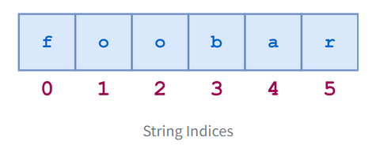

-- The individual characters can be accessed by index as follows:

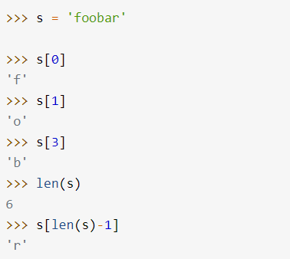

-- Attempting to index beyond the end of the string results in an error:

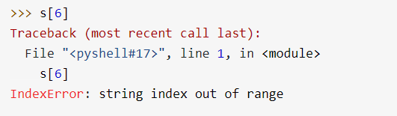

-- String indices can also be specified with negative numbers, in which case indexing occurs from the end of the string backward: -1 refers to the last character, -2 the second-to-last character, and so on.

-- Here is the same diagram showing both the positive and negative indices into the string 'foobar':

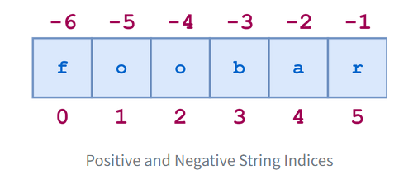

-- Here are some examples of negative indexing:

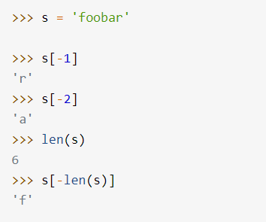

-- Attempting to index with negative numbers beyond the start of the string results in an error:

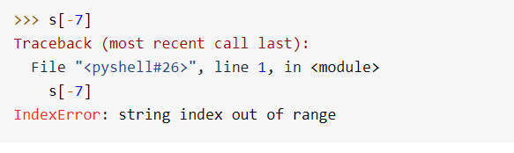

-- For any non-empty string s, s[len(s)-1] and s[-1] both return the last character. There isn’t any index that makes sense for an empty string.